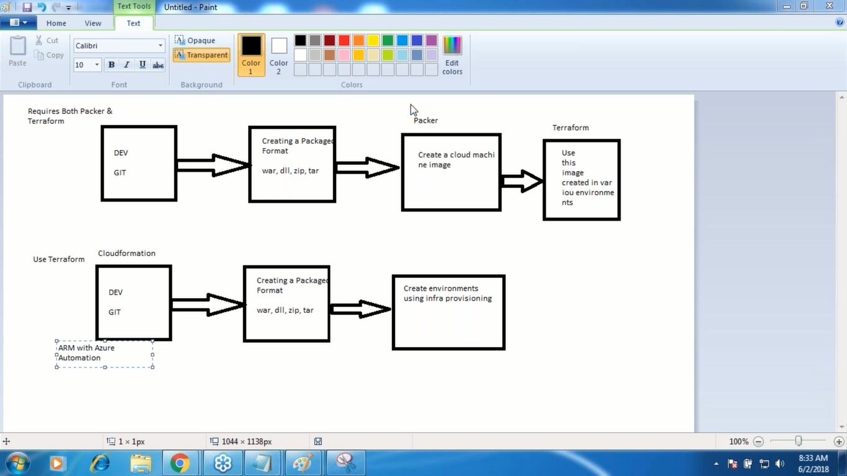

wget <file.ext> -O /path/to/folder/file.ext

<https://github.com/yvusha/newone/blob/master/task.json>

34.230.48.107:8080

how to configure email notification on jenkins

If we need env creation in AWS we can use cloudfromation

If we need env creation in azure we can use ARM.

Reusable image creation we use packer

Env creation we use terraform, it will work on all the clouds that is the reason we prefer terraform.

Terrafrom:

It’s in tf format

Providers:

Resource: Under resource we use provisiners

Output

DataSource

Varible.

Run tf: environment creation , we can put the terrrafrom file in the git but not the state file bcz state file is a binery file

State file: State file maintain the idempotes , whatever we create in AfWS by using tf file. If we run again it will tell that already we have no need again or if we miss anything in the like any security group or any thing it will recreate and we keep these files in S3 buket. Cloud backend or folder backend we use.

Cloud backend is s3buket and blobstorage and folder backend is our local drives.

* Install java

<http://54.213.246.36:8080/>

wget <https://releases.hashicorp.com/packer/0.12.0/packer_0.12.0_linux_amd64.zip>

unzip packer_0.12.0_linux_amd64.zip -d packer

|  |  |
| --- | --- |
|  | sudo mv packer /usr/local/ |

Packer

Command 'sudo' is available in '/usr/bin/sudo'

<http://54.144.93.224:8080/sample/------tomcat7> on ubhantu14.